Name _______________________________________________ Date __________________
Midshipman Fish
Aim: How can counting brain images for reactivity help us better understand the mating behavior of Midshipman Fish?

Do Now: Read the following and complete the visualizing activity below.
The Singing Fish

The plainfin midshipman fish belongs to a family of fish known as toadfish because of their squat, slimy appearance. Midshipman fish live along the Pacific coast from Alaska to Baja California at depths of up to 300 meters, burying themselves in the mud during the day and surfacing at night to feed.

Midshipman fish come in three varieties: females, Type I males and the smaller Type II males.All three types are vocal, emitting short grunts to communicate with one another. Female midshipman fish follow the singing to the Type 1 males' nests, where they lay their eggs.

Draw your Visualization below

Background Information: Female Midshipman Fish react to the humming noise of a Male Type I. The following brain images are from three different female fish. Count all the green blobs (represents whole cell body), then count the green blobs that have a red dot (nucleus). This indicates that they were active around the time of sacrifice. (Images courtesy of Forlano Lab 2014)

Table: Number of Reactions Occurring on Different Female Fish
 | Tally number of green cells (R) | Tally number of green cells with red dot (T) | Total number of green cells with red dot / total number of green cells (T/R) | Percentage of Activity  (T/R X 100)
Female Fish A
Female Fish B
Female Fish C

Graph: Create a bar graph with the percentage of activity for all three fish types. Clearly label the axes, title and use an appropriate scale.

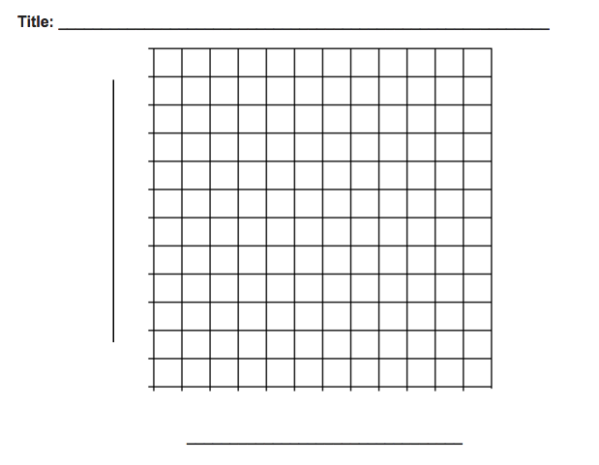

Analysis Questions:
1) Which fish had the most reactions? How do you know?
______________________________________________________________________
______________________________________________________________________
______________________________________________________________________
2) Which fish had the least reactions? How do you know?
______________________________________________________________________
______________________________________________________________________
______________________________________________________________________
3) What was the main idea of this activity?
______________________________________________________________________
______________________________________________________________________
______________________________________________________________________
4) What do you think could happen if all three fish had similar reactions?
______________________________________________________________________
______________________________________________________________________
______________________________________________________________________
5) How does this activity and the overall brain activity of fish compare to human brain activity?
______________________________________________________________________
______________________________________________________________________
______________________________________________________________________

Conclusion:
Using the data and previous knowledge of what you know about the Midshipman fish and their mating behavior, describe the role of females and their brain reactions and how it helps with mating.
______________________________________________________________________
______________________________________________________________________
______________________________________________________________________
______________________________________________________________________
______________________________________________________________________
______________________________________________________________________
______________________________________________________________________
______________________________________________________________________
______________________________________________________________________

