Name _______________________________________________ Date _________________
Midshipman Toadfish
Aim: How can calculating the GSI help us better understand the mating behavior of Midshipman Fish?
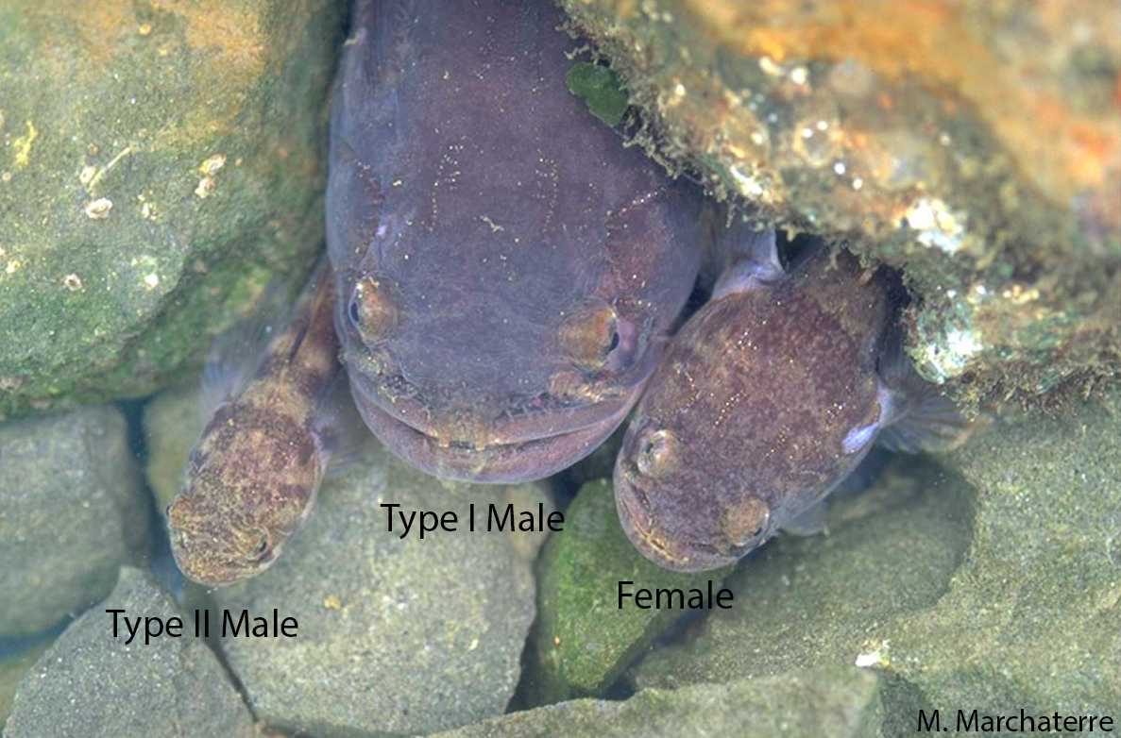

The Midshipman Fish are known for their use of vocalization in mating. Type I males produce a humming noise that is attractive to females. Females lay their eggs in the nest of the male fish that is large because large male fish will better protect their fertilized eggs. The Type II males are unable to produce a humming noise, so they wait for the female to lay their eggs and then sneak over to release their sperm to fertilize them; then the large male will rear the young of the other male too.

The Gonadosomatic Index (GSI) is a tool used to measure the sexual maturity of animals in relation to their ovary and testis development. In this activity, we will measure the GSI on Midshipman Toadfish.

The gonadosomatic index, abbreviated as GSI, is the calculation of the gonad mass as a proportion of the total body mass. It is represented by the formula:

GSI = [Gonad Weight / Total Body Weight] x 100
Table 1
Fish- Male Type I | Length of Fish | Gonad Weight | Total Body Weight | GSI
H | 16.9 | 0.8 | 61.1
M | 15.9 | 0.9 | 54.2
O | 19.6 | 0.8 | 101.4
P | 16.8 | 1.4 | 59.8
Q | 14.4 | 0.8 | 41.3
Average GSI: __________
Table 2
Fish- Male Type II | Length of Fish | Gonad Weight | Total Body Weight | GSI
A | 10.8 | 1.2 | 16.3
F | 11 | 0.7 | 15.4
G | 7.7 | 0.5 | 5.3
N | 8.6 | 0.5 | 6.8
Y | 8.5 | 1.6 | 9.8
Average GSI: __________

Graph 1: Create double line graph comparing the length of the two types of male fish with their GSI. Clearly label the axes, title, use an appropriate scale and include a key.

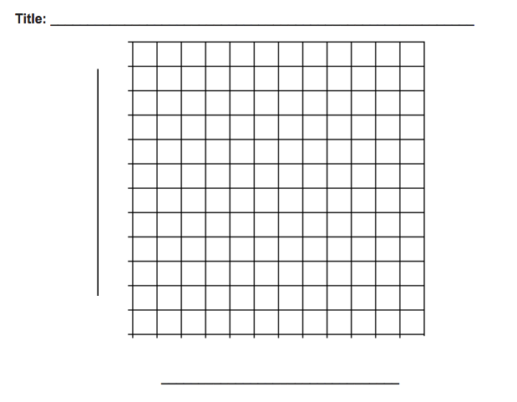
Table 3
Fish- Female | Length of Fish | Gonad Weight | Total Body Weight | GSI
SS | 12.2 | 0.9 | 29.6
OO | 11.9 | 1.2 | 25.2
PP | 13.4 | 10.9 | 32.7
QQ | 13.6 | 9.2 | 37.3
RR | 13.4 | 7.0 | 35.2
Average GSI: __________

Graph 2: Create a bar graph with the average GSI for all three fish types. Clearly label the axes, title and use an appropriate scale.
Analysis Questions:
1) What difference do you see in gonad weight between male Type I and II?
______________________________________________________________________
______________________________________________________________________
______________________________________________________________________
2) Which male fish do you think will have a greater impact when it comes to fertilizing egg for reproduction? Why?
______________________________________________________________________
______________________________________________________________________
______________________________________________________________________
3) What is the major difference between female fish SS and PP? Why do you think this difference occurred?
______________________________________________________________________
______________________________________________________________________
______________________________________________________________________
4) How does the average GSI for females compare with male types I and II?
______________________________________________________________________
______________________________________________________________________
______________________________________________________________________
5) Why do type II male have a higher GSI compared to type I male?
______________________________________________________________________
______________________________________________________________________
______________________________________________________________________

Conclusion:
Using the data, the GSI calculated and the graph you created, describe the relationship between the fish organisms, their Gonad size and their length. What are some major differences that you see? Relate all this information with previous knowledge of what you know about the Midshipman fish and their mating behavior (How do Midshipman fish mate? Why are there two types of males? What are the roles of the two types of males?, etc).
______________________________________________________________________
______________________________________________________________________
______________________________________________________________________
______________________________________________________________________
______________________________________________________________________
______________________________________________________________________
______________________________________________________________________
______________________________________________________________________
______________________________________________________________________

