Name ______________________________________________ Date ___________________
Midshipman Fish
Aim: How do we determine the relationship between structure and behavior in Plainfin Midshipman fish?

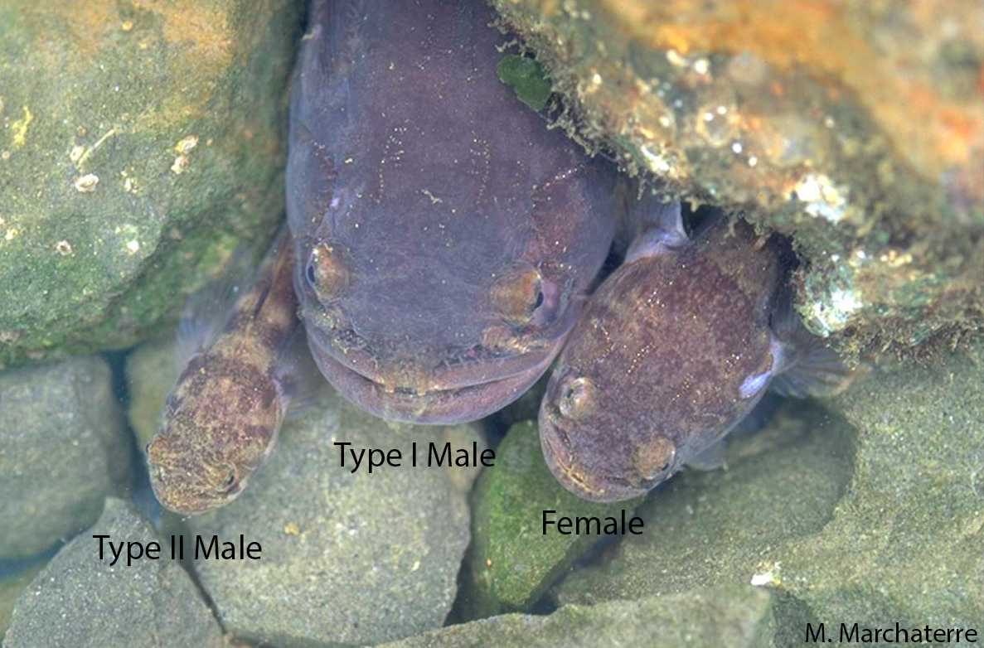

BEFORE READING, write down your hypothesis to the following problem. Then, read the following article and answer the article questions.
Problem: | Why do midshipman fish sing?
Hypothesis: | IF _____________________________________________________  ________________________________________Then___________  _______________________________________________________

What Singing Fish Reveal about Speech and Hearing

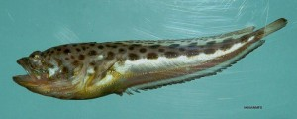
Adapted Edition By Ferris Jabr on October 16, 2012

One type of midshipman fish, the Atlantic midshipman (Porichthys plectrodo). Note the photophores along its belly. (Credit: SEFSC Pascagoula Laboratory; Collection of Brandi Noble, NOAA/NMFS/SEFSC, via Wikimedia Commons

The plainfin midshipman fish (Porichthys notatus) belongs to a family of fish known as toadfish because of their squat, slimy appearance. Midshipman fish live along the Pacific coast from Alaska to Baja California at depths of up to 300 meters, burying themselves in the mud during the day and surfacing at night to feed.

Midshipman fish come in three varieties: females, Type I males and the smaller Type II males. All three types are vocal, emitting short grunts to communicate with one another, but Type 1 males are the most voluble by far. In the spring and summer, Type 1 males head to shallow waters, excavate nests beneath rocks along the shoreline, hunker down and start to sing, using sonic muscles surrounding their inflatable swim bladders to hum for up to an hour at a time. This humming, which people have described a droning motorboat or an orchestra of mournful oboes, is so loud that it has been known to wake houseboat owners in San Francisco and Sausalito. Female midshipman fish follow the singing to the Type 1 males' nests, where they lay their eggs. Type II males are little sneaks. They also listen for the calls of Type I males and look similar enough to females to slip past a Type 1 male and fertilize any recently laid eggs in his nest before the Type 1 male gets a chance to release enough of his own sperm.

Bass and his colleagues have also discovered that Type 1 male midshipman fish deliberately desensitize their ears to sound when they are humming to avoid damaging their ear hair cells. At the same time that a male midshipman fish's brain stimulates muscles surrounding the swim bladder, it sends electrochemical messages to ear hair cells, essentially telling them to put in earplugs. These two types of signals happen in sync about 100 times every second. Since all vertebrate brains have similar living links to the ears, Bass and his colleagues propose that four-limbed animals like echolocating bats, barking dogs and human pop stars might rely on related acoustic strategies to protect and preserve their hearing when they are making loud sounds.

Now, Elizabeth Whitchurch, currently at Humboldt State University, and her colleagues have shown that Type 1 males have bigger distances between their swim bladders and their ears than Type II males and females. This adaptation may further help Type I males protect their hearing during the mating season. Whitchurch presented her findings at the Society for Neuroscience's annual meeting.

When it comes to animal research on speech, music and hearing, songbirds like zebra finches and squeaking mice usually get the spotlight. Who would have thought that a humble mud-dwelling toadfish would give scientists so much to say about vocal communication? In honor of this unlikely inspiration, let's make some noise: three cheers—or grunts—for the plainfin midshipman fish!

Article Questions:
Describe three facts about the Midshipman fish.
___________________________________________________________________________
___________________________________________________________________________
___________________________________________________________________________
How are Type I fish different from Type II males?
___________________________________________________________________________
___________________________________________________________________________
___________________________________________________________________________
___________________________________________________________________________
What did Bass and his colleagues discover regarding the different fish and their behavior?
___________________________________________________________________________
___________________________________________________________________________
___________________________________________________________________________
___________________________________________________________________________
Does your hypothesis support Bass’ conclusion?
___________________________________________________________________________
___________________________________________________________________________
How could this experiment be improved?
___________________________________________________________________________
___________________________________________________________________________
Exit Ticket: Choose one of the following:
- Write a CLAIM, EVIDENCE, REASONING (CER) paragraph answering the following question.
- Draw a before/during/ after picture to answer the following question.

What is the relationship between structure and behavior in the midshipman fish?
___________________________________________________________________________
___________________________________________________________________________
___________________________________________________________________________
___________________________________________________________________________
___________________________________________________________________________
___________________________________________________________________________

Before

During

After

Link to the full Scientific American Article.
https://blogs.scientificamerican.com/brainwaves/what-singing-fish-reveal-about-speech-and-hearing/

Possible literary graphic organizers to help student comprehension.
https://www.eduplace.com/graphicorganizer/pdf/5Ws.pdf
http://www.thecurriculumcorner.com/thecurriculumcorner456/wp-content/pdf/readingworkshop/fqr/fqr456.pdf

http://www.nytimes.com/2004/07/20/science/observatory.html

Ears Burning Thinking of You
By HENRY FOUNTAIN JULY 20, 2004

Bickering partners may have the ability to tune each other out, but the midshipman fish does the opposite: Females tune their hearing during breeding season to detect the mating calls of males.
That's the finding of researchers at Cornell, who report in the journal Science that the tuning is accomplished by the hormones estrogen and testosterone. The chemicals alter the sensitivity of hair cells in the inner ear so that they are more receptive to higher frequencies.
''We've shown that electrical activity in the cells has changed in response to the hormones,'' said Dr. Andrew H. Bass, a professor of neurobiology and behavior and a lead author of the study along with Dr. Joseph Sisneros, who is now at the University of Washington.
The midshipman fish lives off the Pacific coast and comes into shallow intertidal waters to breed. By rapidly contracting muscles around an internal air sac, males emit loud mating calls that are something like the hum from a poorly grounded hi-fi system.
Waterside residents have been known to be kept awake by the buzz, which the males can produce continuously for an hour or more. ''Besides whales and dolphins, they are the vocal champions of the sea,'' Dr. Bass said. (A sample of the sound can be heard online all week at nytimes.com/science.)
Since higher-frequency sounds travel farther in shallower water, he said, it is in the females' interest to be able to hear higher frequencies. Without the hormone-induced changes, they would be less likely to find a mate.
The mechanism by which the hormones alter hair-cell sensitivity will be researched further, Dr. Bass said. Any findings could have implications for human hearing because humans have hair cells in their ears, too, and secrete the same hormones.
Already some research has suggested that hormones may cause the increased hearing sensitivity that some women report during parts of the menstrual cycle. And women with the chromosomal disorder Turner's syndrome, who lose ovarian function at an early age, often have some hearing loss as well.
The midshipman fish offers a good model to work with, Dr. Bass said, because ''everything in their lives is about making sound and hearing sound.''
''I'm not about to say that what we found is going to help us cure deafness,'' he added, ''but this sort of fundamental discovery has important applications for what goes on in humans.''

